|  |  |  |  |  |
| --- | --- | --- | --- | --- |
| GROUP |  |  |  | ACC |
| DATE OF LAB WORK |  |  |  |  |
| NAME | 1 | PRATAMA AJI NUR RAHMAN | D400154003 |  |
|  | 2 | AMNADUNY AKHARA | D400154006 |  |
|  | 3 | JESKI SAPUTRA | D400154009 | ACC DATE : |
|  | 4 | MILZAM WAFI AZHAR | D400154007 | REVISE DATE : |

MODULE 3

FLEXIBLE AND ABSOLUTE TIMING ON

1. PURPOSE

1. To know operating system in Arduino using FreeRTOS

2. To know the use of Flexible and Timing ON in FreeRTOS

1. TOOLS AND EQUIPMENT
2. Laptop
3. Arduino
4. BASIC THEORY

Most operating systems appear to allow multiple programs or threads to execute at the same time. This is called multi-tasking. In reality, each processor core can only be running a single program at any given point in time. A part of the operating system called the scheduler is responsible for deciding which program to run when, and provides the illusion of simultaneous execution by rapidly switching between each program.

The scheduler in a Real Time Operating System (RTOS) is designed to provide a predictable (normally described as deterministic) execution pattern. This is particularly interesting for embedded systems, like the Arduino devices, as embedded systems often have real time requirements.

Traditional real time schedulers, such as the scheduler used in [FreeRTOS](http://www.freertos.org/RTOS.html), achieve determinism by allowing the user to assign a priority to each thread of execution. The scheduler then uses the priority to know which thread of execution to run next. In FreeRTOS, a thread of execution is called a Task.

1. RESULT OF LAB WORK

D.1 Script Program

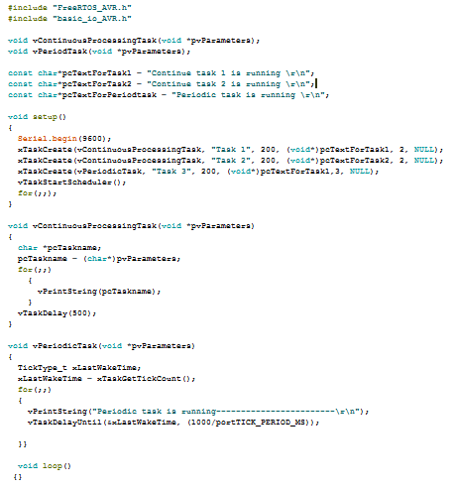

1. ANALYSIS
2. Abs Time (absolute time)

This is the total 'time' that the task has actually been executing (the total time that the task has been in the Running state). It is up to the user to select a suitable time base for their application.

1. FreeRTOS can optionally collect information on the amount of processing time that has been used by each task. The ’ [vTaskGetRunTimeStats()](https://www.freertos.org/a00021.html#vTaskGetRunTimeStats)’  API function can then be used to present this information in a tabular format, as shown on the right
2. CONCLUSION

While the LED outputs have both maximum and minimum time constraints, there is a large timing band within which they can function.